SeesharpTools.JXI.DSP
user manual

文档版本

日期 | 版本 | 修订说明 | 修订人签署
2017/11/11 | 1.0.0 | 初稿 | 谢晓姣
2017/12/07 | 1.0.1 | 修改产生高斯白方法接口 | 谢晓姣

目录
1. Conditioning 3
1.1. Conditioning介绍 3
1.2. FIRFilter 4
1.2.1. FIR滤波器介绍 4
1.2.2. 范例 5
1.3. IIRFilter 7
1.3.1. IIR滤波器介绍 7
1.3.2. 范例 8
1.4. Synchronization 12
1.4.1. 同步介绍 12
1.4.2. 范例 12
2. Generation 16
2.1. Generation介绍 16
2.2. GaussianWhiteNoise 16
2.2.1. GaussianWhiteNoise介绍 16
2.2.2. 范例 16
3. JTFA 18
3.1. JTFA介绍 18
3.1.1. 范例 19
4. Measurement 21
4.1. Measurement介绍 21
4.2. FrequencyResponseFunction 21
4.2.1. FrequencyResponseFunction介绍 21
4.2.2. 范例 21
4.3. HarmonicAnalysis 23
4.3.1. HarmonicAnalysis介绍 23
4.3.2. 范例 24
4.4. SquarewaveMeasurements 26
4.4.1. SquarewaveMeasurements介绍 26
4.4.2. 范例 26
4.5. ThirdOctaveAnalysis 27
4.5.1. ThirdOctaveAnalysis介绍 27
4.5.2. 范例 28

Conditioning

Conditioning介绍
Conditioning包括FIR滤波器，IIR滤波器，以及同步。

FIRFilter

FIR滤波器介绍
实现直接型FIR滤波器有2个步骤：
- 使用fir.Coefficients属性配置滤波器系数。
- 调用Filter进行滤波。

滤波器的系数可以用MATLAB的FDAtool设计。然后导出系数。
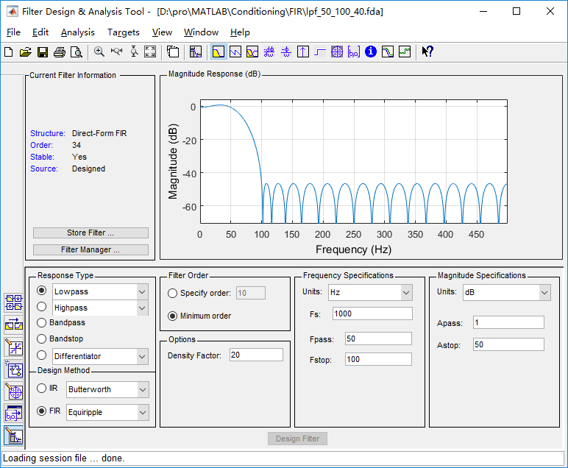
图 1.1 FIR滤波器设计

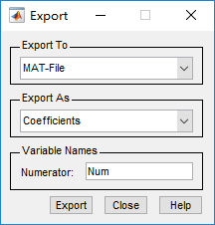
图 1.2 导出FIR滤波器系数

范例
/*************************
* LPF
* passFreq=50Hz
* stopFreq=100Hz
* 带外衰减40db
* 采样频率1000Hz
* *************************/
double[] coe = new double[] { 0.00194150175769345,- 0.00169793575520208,- 0.00426956799325628,- 0.00829350380976647,- 0.0132303432212115,- 0.0181544335557185,- 0.0217585679131809,- 0.0225134101549763,- 0.0189478446411358,- 0.00995128109977753,0.00489205937905203,0.0250974062726473, 0.0492006450550267, 0.0748863114260257, 0.0992878499995790, 0.119424371366942, 0.132695897659600, 0.137328720011526, 0.132695897659600 ,0.119424371366942 , 0.0992878499995790,0.0748863114260257,0.0492006450550267,0.0250974062726473, 0.00489205937905203,- 0.00995128109977753,- 0.0189478446411358,- 0.0225134101549763,- 0.0217585679131809,- 0.0181544335557185,- 0.0132303432212115 - 0.00829350380976647,- 0.00426956799325628,- 0.00169793575520208,0.00194150175769345 };
double[] sinWave1 = new double[1000];
double[] sinWave2 = new double[1000];
Generation.SineWave(ref sinWave1, 1, 0, 10, 1000);
Generation.SineWave(ref sinWave2, 1, 0, 120, 1000);
ArrayCalculation.Add(sinWave1, sinWave2, ref sinWave1);
double[] sinWaveFir = new double[1000];
var fir = new FIRFilter();
fir.Coefficients = coe;
fir.Filter(sinWave1, ref sinWaveFir);
VISN_Plot.PlotData("FIR_LPF1", sinWaveFir);
VISN_Plot.PlotData("FIR_LPF2", sinWave1);
结果：
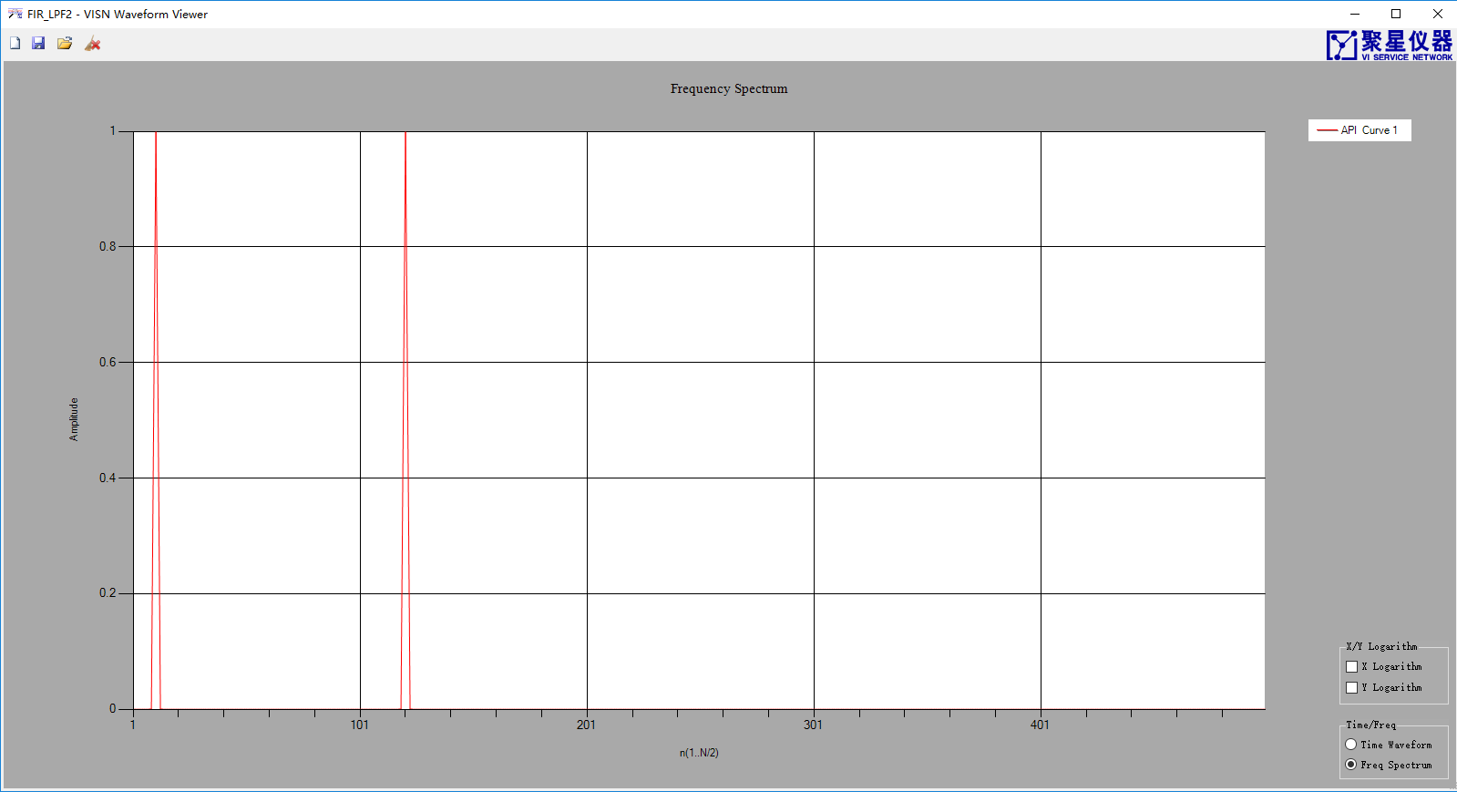
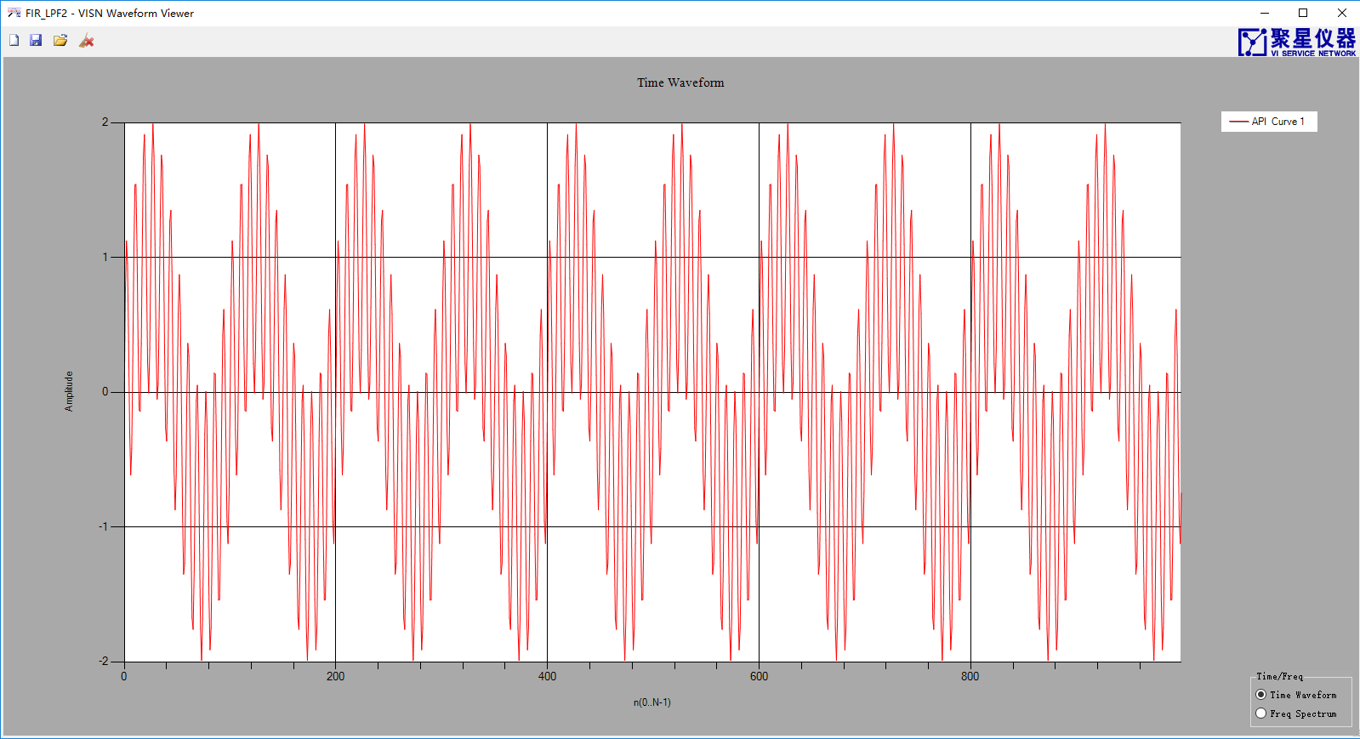
图 1.3滤波前的信号以及频谱
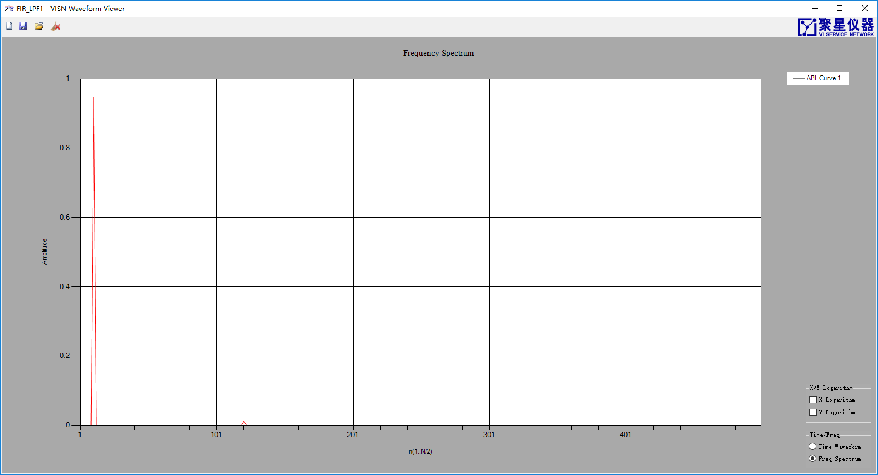
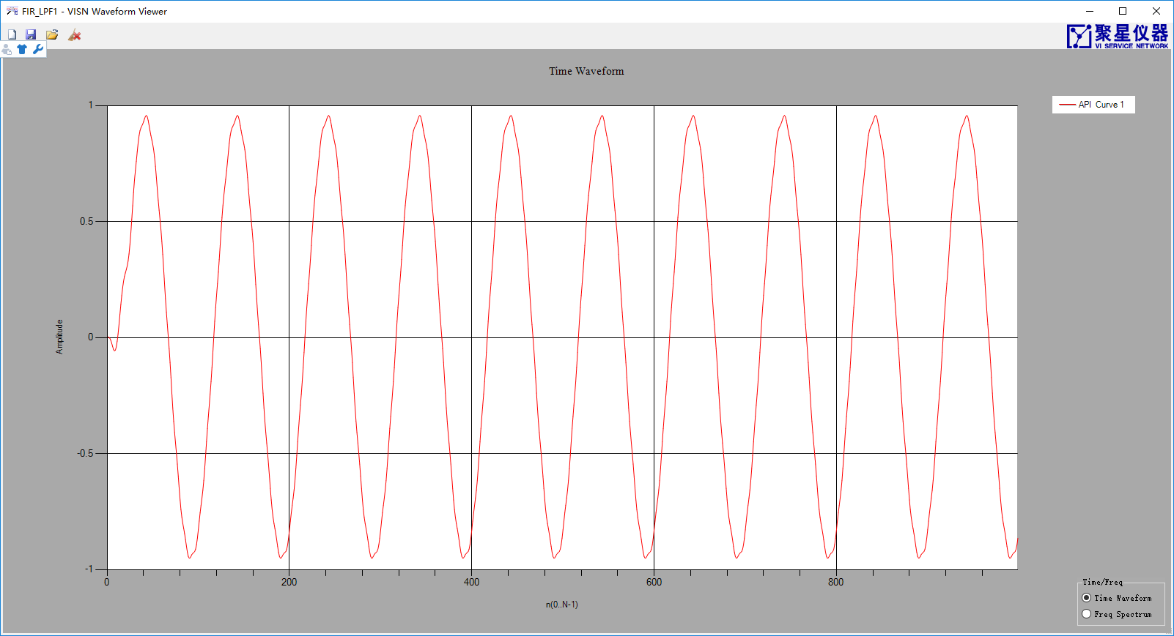
图 1.4滤波后的信号以及频谱

注意：改变滤波器系数后需要调用Reset（）清除状态寄存器！

IIRFilter

IIR滤波器介绍
实现直接II型IIR滤波器有2个步骤：
（1）使用SetCoefficients（）配置滤波器系数。
（2）调用Filter进行滤波。

滤波器的系数可以用MATLAB的FDAtool设计。
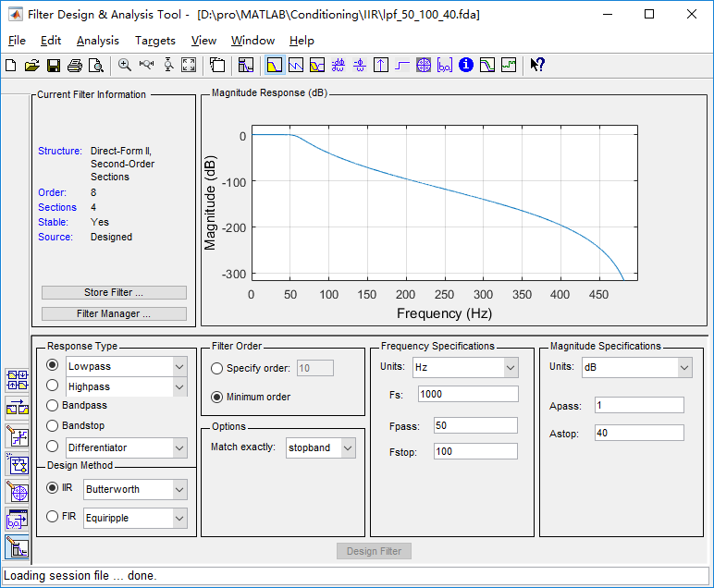
图 1.5 IIR滤波器设计
设计完滤波器后，在文件(File)的下拉菜单选择Export，得到矩阵SOS和G
用[b,a]=sos2tf(SOS);得到滤波器系统函数的分子分母多项式系数，只是差了一个比例因子k。
K=cumprod(G);
k=K(end);
滤波输出结果filteredpWave可以这样求：
filteredpWave=filter(b,a,pWave)*k;
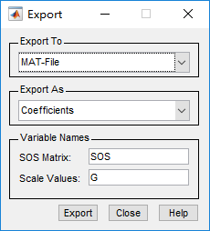
图 1.6 导出系数

范例
/*************************
* LPF
* passFreq=50Hz
* stopFreq=100Hz
* 带外衰减40db
* 采样频率1000Hz
* *************************/
double[] sinWave1 = new double[1000];
double[] sinWave2 = new double[1000];
Generation.SineWave(ref sinWave1, 1, 0, 10, 1000);
Generation.SineWave(ref sinWave2, 1, 0, 120, 1000);
ArrayCalculation.Add(sinWave1, sinWave2, ref sinWave1);
double[] sinWaveIir = new double[1000];
double[] numerator = new double[] { 1, 8, 28, 56, 70, 56, 28, 8, 1 };
double[] demoniatorr = new double[] { 1,- 6.14833128577259 , 16.7106178322332, - 26.1940863217919 , 25.8773677909964 ,- 16.4863518823100 ,6.61072693847043, - 1.52457047404531 , 0.154752511303108 };
double k = 4.887073568907229e-07;
var iir = new IIRFilter();
iir.SetCoefficients(numerator, demoniatorr);
iir.Filter(sinWave1, ref sinWaveIir);
ArrayCalculation.MultiplyScale(ref sinWaveIir, k);
VISN_Plot.PlotData("IIR_LPF1", sinWaveIir);
VISN_Plot.PlotData("IIR_LPF2", sinWave1);
结果：
图 1.7滤波前的信号以及频谱
图 1.8滤波后的信号以及频谱

using MathNet.Numerics.Data.Matlab;
using MathNet.Numerics.LinearAlgebra;

/*************************
* LPF
* passFreq=0.2
* stopFreq=0.3
* 带外衰减40db
* 采样频率1000Hz
* SOS
* *************************/
double[] sinWave1 = new double[1000];
double[] sinWave2 = new double[1000];
Generation.SineWave(ref sinWave1, 1, 0, 10, 1000);
Generation.SineWave(ref sinWave2, 1, 0, 350, 1000);
ArrayCalculation.Add(sinWave1, sinWave2, ref sinWave1);
string path = Environment.CurrentDirectory;
//清空系数矩阵
double [,] SOS = null;
double [] G = null;

//读.mat文件
Matrix<double> MATLAB_SOS = MatlabReader.Read<double>(path+ @"\lpf_0p2_0p3_40db_SOS.mat", "SOS");
//创建滤波器系数数组
SOS = new double[MATLAB_SOS.RowCount,MATLAB_SOS.ColumnCount];
//获取滤波器系数
var tmp_SOS = ((MathNet.Numerics.LinearAlgebra.Double.DenseMatrix)MATLAB_SOS).Values;
//拷问数组
for (int i = 0; i < SOS.GetLength(0); i++)
{
for (int j = 0; j < SOS.GetLength(1); j++)
{
SOS[i, j] = tmp_SOS[i + j*( SOS.GetLength(1)-1)];
}
}

//读.mat文件
Matrix<double> MATLAB_G = MatlabReader.Read<double>(path + @"\lpf_0p2_0p3_40db_SOS.mat", "G");
//创建滤波器系数数组
G = new double[ MATLAB_G.RowCount];
//获取滤波器系数
var tmp_G = ((MathNet.Numerics.LinearAlgebra.Double.DenseMatrix)MATLAB_G).Values;
//拷问数组
Array.Copy(tmp_G, G, MATLAB_G.RowCount);

double[] sinWaveIir = new double[1000];
var iir = new IIRFilter();
iir.IsSOS = true;
iir.SetCoefficients(SOS, G);
iir.Filter(sinWave1, ref sinWaveIir);
AnalogWaveformChart.Plot("IIR_After", sinWaveIir);
AnalogWaveformChart.Plot("IIR_Before", sinWave1);

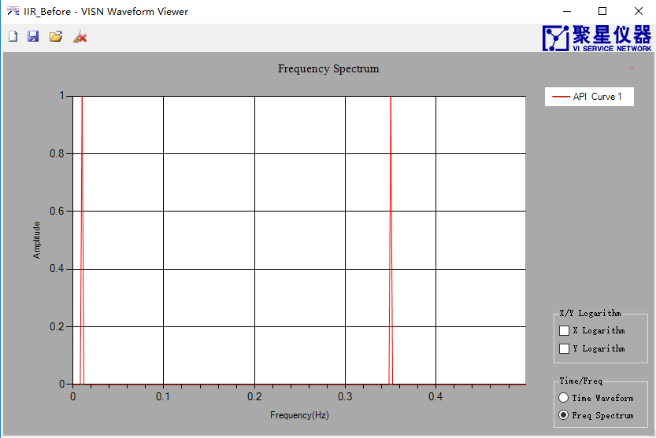
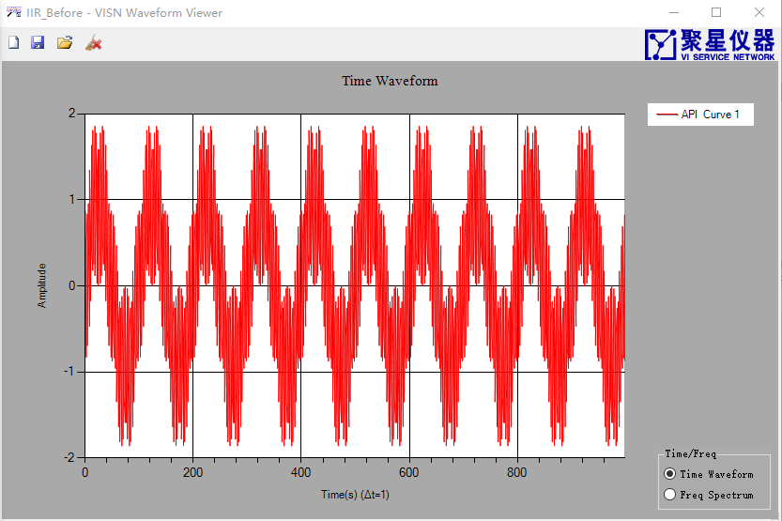
图 1.9滤波前的信号以及频谱
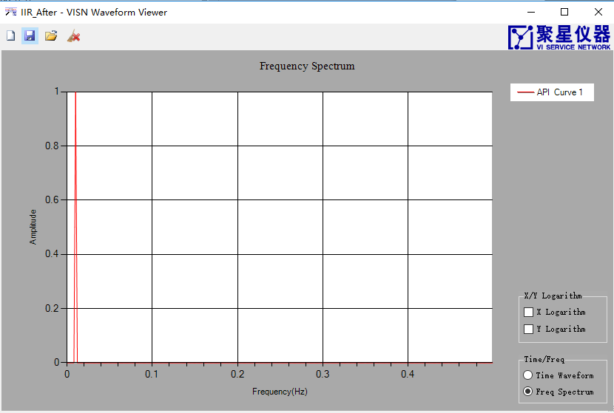
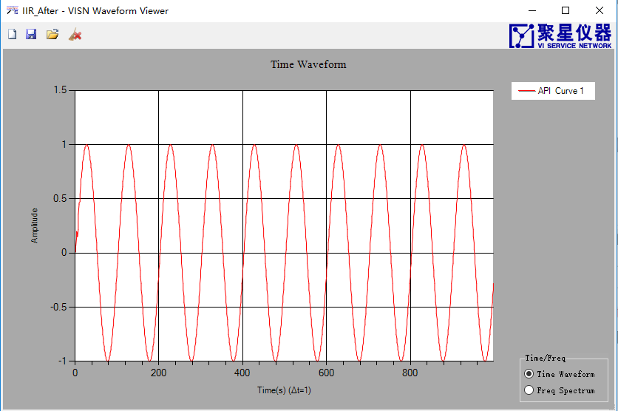
图 1.10滤波后的信号以及频谱

注意：改变滤波器系数后需要调用Reset（）清除状态寄存器！

Synchronization

同步介绍
实现扫描采集卡多通道数据同步有1个步骤：
（1）调用SyncWaveform(double[,] data, double ChannelShiftSamples)进行数据同步。ChannelShiftSamples为采样点数。

范例
double[] sinWave1 = new double[1000];
double[] sinWave2 = new double[1000];
Generation.SineWave(ref sinWave1, 1, 0, 10, 1000);
Generation.SineWave(ref sinWave2, 1, 360.0/2000, 10, 1000);
double[,] rawWaveform = new double[1000, 2];
ArrayManipulation.Connected_2D_Array(sinWave1, sinWave2, ref rawWaveform);
double[,] rawWaveformT = new double[rawWaveform.GetLength(1), rawWaveform.GetLength(0)];
ArrayManipulation.Transpose(rawWaveform, ref rawWaveformT);
var syncWaveform = Synchronization.SyncWaveform(rawWaveformT, 0.5);
AnalogWaveformChart.Plot("RawWaveform", rawWaveformT);
AnalogWaveformChart.Plot("SyncWaveform", syncWaveform);
结果：
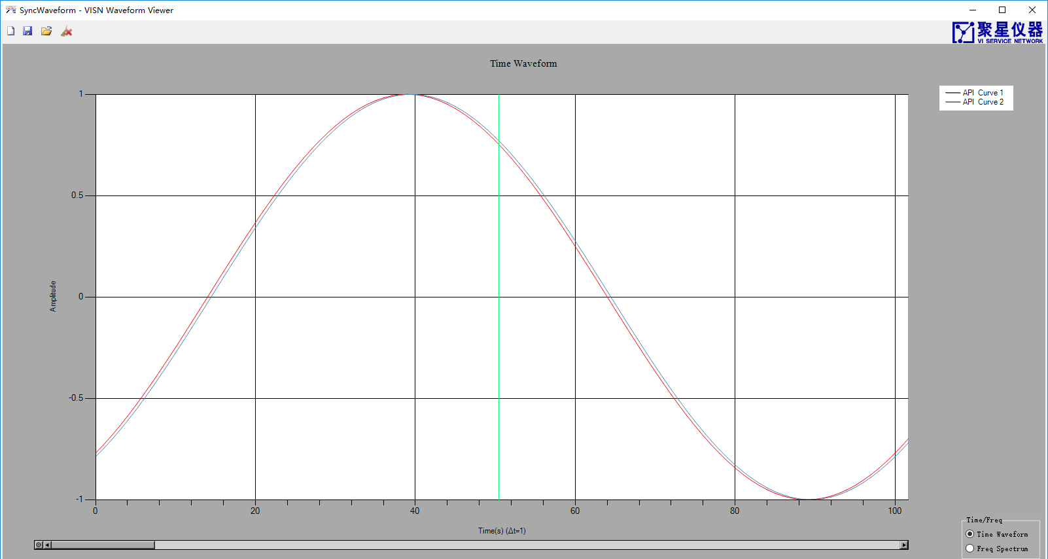
图 1.11同步前
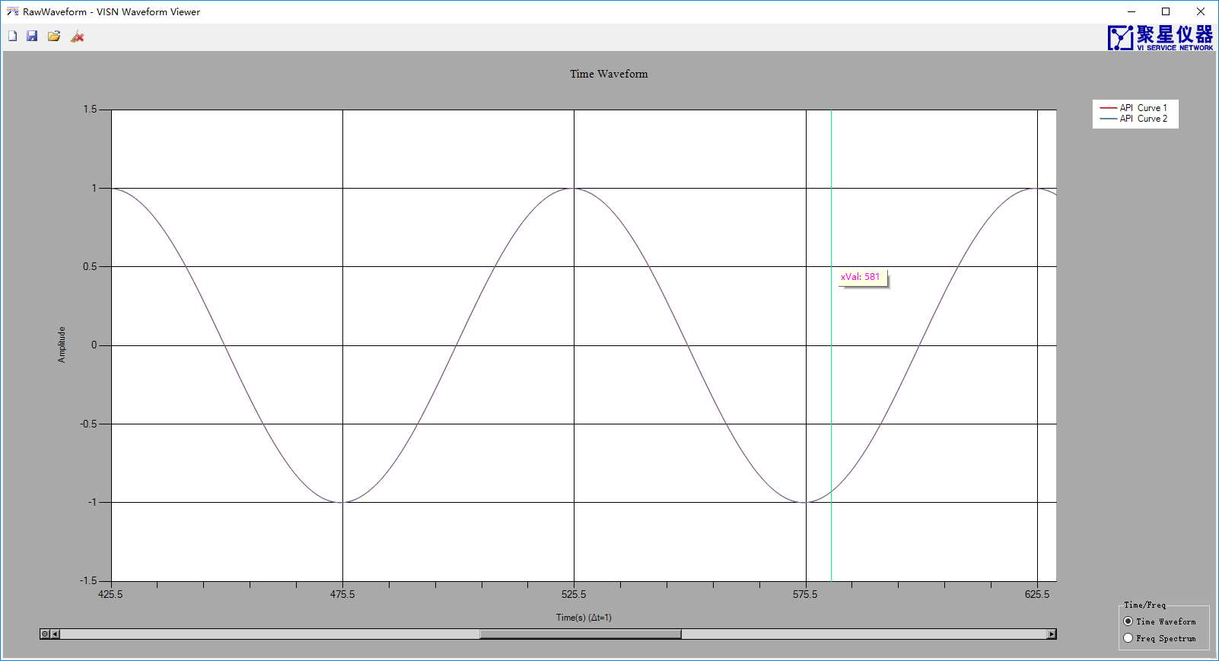
图 1.12同步后

Resample

重采样介绍
提供多个重载：
double[] ResampleWaveform(double[] data, double delay, double dt)
double[] ResampleWaveform(double[] data, double delay）
Complex[] ResampleWaveform(Complex[] data, double delay, double dt)

其中data为输入数据，delay为延时（单位为采样点数），dt为新采样间隔（单位为采样点数），比如delay=0.5，dt=0.1，则重采样后的数据的采样率为输入信号的10倍，并偏移了0.5个采样点（输入数据的采样率而言）。

范例
/*****************************
* 改变采样率，重采样后的信号与按照新采样率采样的信号只存
*在一个时延
* dt=0.3
* delay=0;
* ***************************/
double dt = 0.3;
double[] sinWave1 = new double[1000];
double[] sinWave2 = new double[(int)((sinWave1.Length -2*85)/dt)];
double sampleRate = 1000;
double freq = 10;
JY.DSP.Fundamental.Generation.SineWave(ref sinWave1, 1, 0, freq, sampleRate);
JY.DSP.Fundamental.Generation.SineWave(ref sinWave2, 1, 85*360*freq/sampleRate, freq, sampleRate/dt);
var ResWaveform2 = Resample.ResampleWaveform(sinWave1, 0, dt);
double[,] rawWaveform = new double[sinWave2.Length , 2];
ArrayManipulation.Connected_2D_Array(ResWaveform2 , sinWave2, ref rawWaveform);
double[,] rawWaveformT = new double[rawWaveform.GetLength(1), rawWaveform.GetLength(0)];
ArrayManipulation.Transpose(rawWaveform, ref rawWaveformT);
AnalogWaveformChart.Plot("ResWaveform2 ", rawWaveformT);
结果：

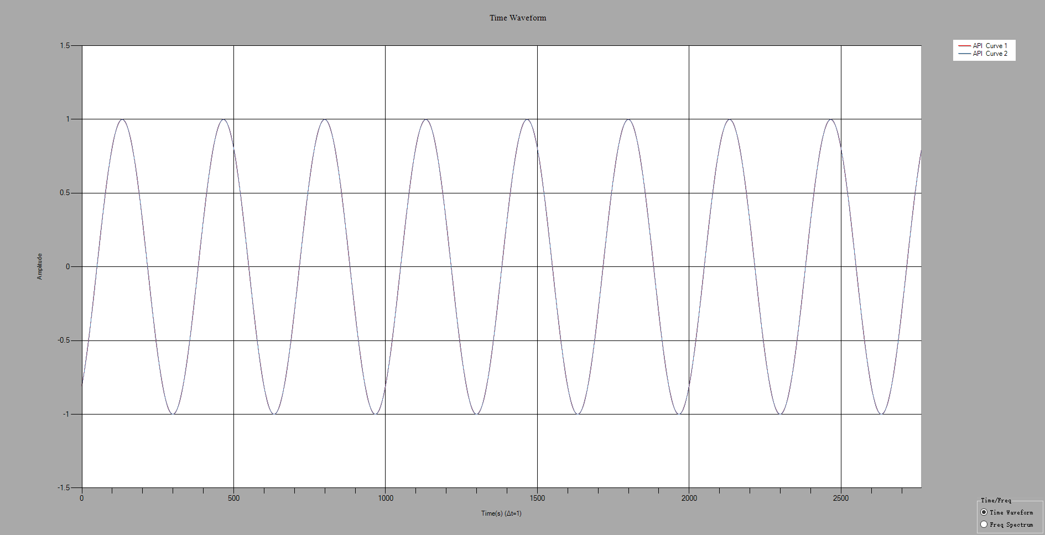
图 1.13重采样

Generation

Generation介绍
Generation包括高斯白噪声的生成。

GaussianWhiteNoise

GaussianWhiteNoise介绍
如果一个噪声，它的瞬时值服从高斯分布（正态分布,u=0），而它的功率谱密度又是均匀分布的，则称它为高斯白噪声。
正态分布的概率密度函数的表达式如下：
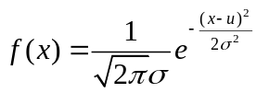 公式 2.1

范例
/***********************************
* 产生服从标准正态分布的高斯白噪声
* 标准差：1
* *********************************/
int Length = 1000000;
var noise = new double[Length];
int[] histgram=new int[500];
double[] histgramTemp = new double[histgram.Length];
double[] intervals = new double[500];
JXI.DSP.Generation.Generation.GaussianWhiteNoise(ref noise, 1);
ProbabilityStatistics.Histogram(noise, ref histgram, ref intervals);
for (int i = 0; i < histgram .Length ; i++)
{
histgramTemp[i] = (double)histgram[i];
}
AnalogWaveformChart.Plot("histgram", histgramTemp);
AnalogWaveformChart.Plot("intervals", intervals);
AnalogWaveformChart.Plot("noise", noise);
结果：

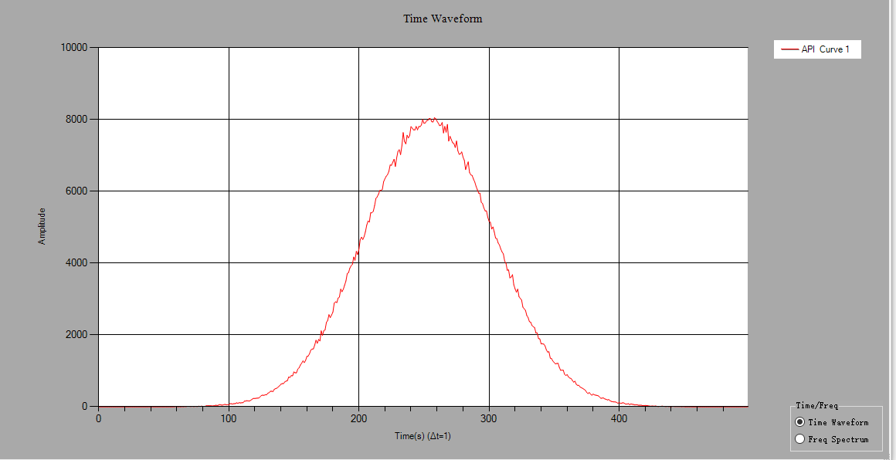
图 2.14 histgram
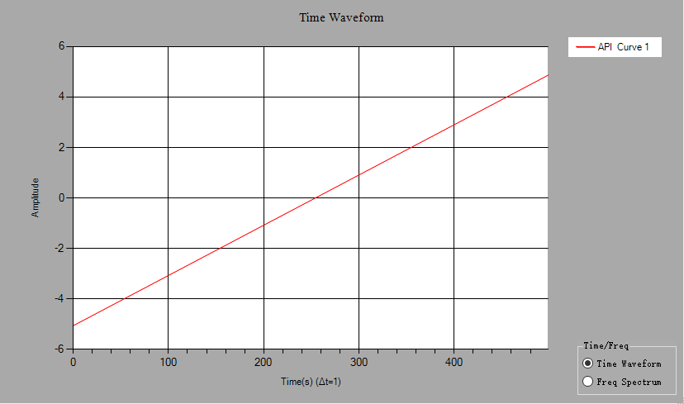
图 2.15 intervals

JTFA

JTFA介绍
JTFA(时频联合分析)，可以获取信号的时频分析后的二维数组，行代表频率（递增），列代表时间（递增）或者强度图（红色最强）。
假设时域信号如Error: Reference source not found所示，频率、幅值随时间变化而变化。
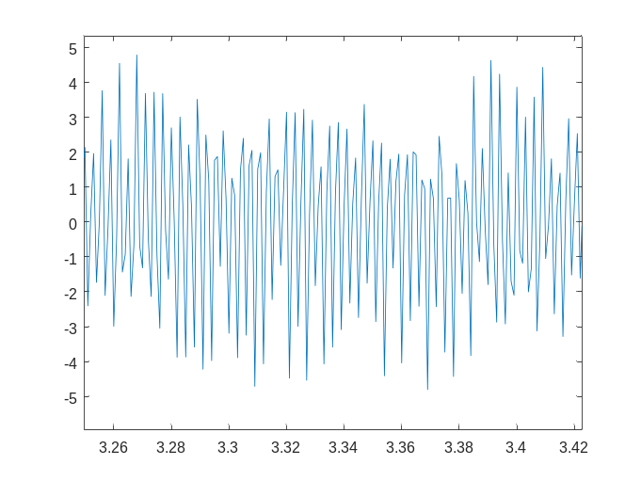
图 3.16时域信号
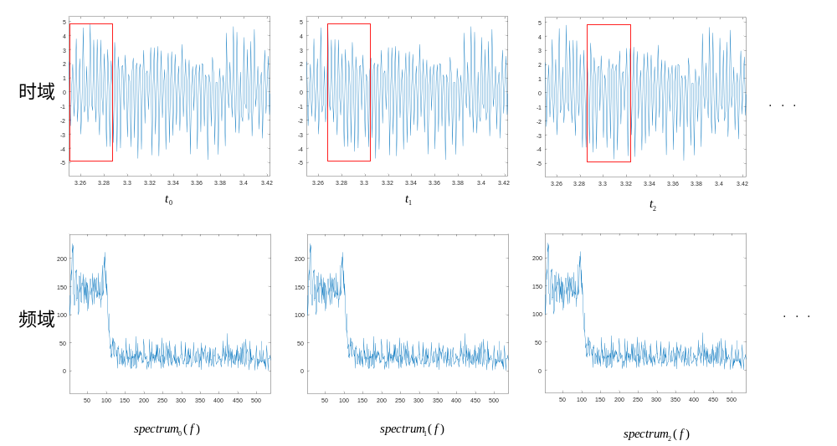
图 3.17 窗口滑动
假设窗的长度为WindowLength，窗口滑动的间隔为WindowLength/4（取整），如图所示，将窗内的时域信号进行短时傅里叶变换（STFT），得到表示频谱的一维数组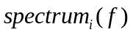，（i为滑动窗口的次数，对于复数信号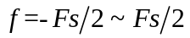，对于实数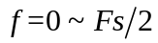），从而得到一个二维数组:
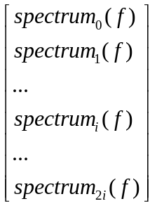
从而得到包含时间、频率、幅值信息的二维数组。

注意：使用同一个任务进行多次JTFA运算时，如果不想上一次运算的保存的数据影响下一次运算时，需要Reset（）,输出频谱、强度图的横坐标为频率，纵坐标为时间。

范例
/*******************************
* 输入信号为实数
* ******************************/
int Length = 1000;
double[] sin = new double[Length];
double[] noise = new double[Length];
double freqSin = 10;
Generation.SineWave(ref sin, 1, 0, freqSin, 1000);
Generation.UniformWhiteNoise(ref noise, 0.05);
ArrayCalculation.Add(sin, noise, ref sin);
JTFATask task = new JTFATask();
task.ColorTable = JTFATask.ColorTableType.Rainbow;
task.WindowType = FFTWindowType.None;
task.FrequencyBins = 500;
task.SampleRate = 1000;
double[,] JTFASpectrum = new double[task.FrequencyBins / 2, 5];
double df;
task.GetJTFA(sin, ref JTFASpectrum,out df);
Bitmap image = new Bitmap(750, 250);
task.GetImage(JTFASpectrum, ref image);

/*******************************
* 输入信号为复数
* ******************************/
int Length = 1000;
double[] sin = new double[Length];
double[] cos = new double[Length];
double freqSin = 10;
JY.DSP.Fundamental.Generation.SineWave(ref sin, 1, 0, freqSin, 1000);
JY.DSP.Fundamental.Generation.SineWave(ref cos, 1, 90, freqSin, 1000);
Complex[] signal = new Complex[Length];
for (int i = 0; i < Length; i++)
{
signal[i] = new Complex(cos[i], sin[i]);
}
JTFATask task = new JTFATask();
task.ColorTable = JTFATask.ColorTableType.Rainbow;
task.WindowType = FFTWindowType.None;
task.FrequencyBins = 500;
task.SampleRate = 1000;
double[,] JTFASpectrum = new double[task.FrequencyBins , 5];
double df;
double valueFreq = 1.0 / 2;
task.GetJTFA(signal, ref JTFASpectrum, out df);
Bitmap image = new Bitmap(750, 250);
task.GetImage(JTFASpectrum, ref image);

Measurement

Measurement介绍
Measurement包括频率响应函数、谐波分析、方波测量、1/3倍频程分析。

FrequencyResponseFunction

FrequencyResponseFunction介绍
提供获取系统幅度响应和相位响应函数；
①幅度响应：double[] GetMagenitude(double[] inputWaveform, double[] outputWaveform, bool inDB, AverageParam Average)

②相位响应：double[] GetPhase(double[] inputWaveform, double[] outputWaveform,bool inDegree,AverageParam Average)

其中inputWaveform为输入系统的信号，outputWaveform为inputWaveform经过系统后的信号，inDB/inDegree为真表示系统响应用dB表示，Average表示平均参数

范例
/***********************
* FIR LPF
* passFreq=50Hz
* stopFreq=100Hz
* 带外衰减40db
* 采样频率1000Hz
* ************************/
double Fs = 1000;
int freqLines = 500; //set frequency resolution here
double df = Fs / 2 / freqLines;
double[] coe = new double[] { 0.00194150175769345, -0.00169793575520208, -0.00426956799325628, -0.00829350380976647, -0.0132303432212115, -0.0181544335557185, -0.0217585679131809, -0.0225134101549763, -0.0189478446411358, -0.00995128109977753, 0.00489205937905203, 0.0250974062726473, 0.0492006450550267, 0.0748863114260257, 0.0992878499995790, 0.119424371366942, 0.132695897659600, 0.137328720011526, 0.132695897659600, 0.119424371366942, 0.0992878499995790, 0.0748863114260257, 0.0492006450550267, 0.0250974062726473, 0.00489205937905203, -0.00995128109977753, -0.0189478446411358, -0.0225134101549763, -0.0217585679131809, -0.0181544335557185, -0.0132303432212115 - 0.00829350380976647, -0.00426956799325628, -0.00169793575520208, 0.00194150175769345 };
double[] noiseInput = new double[1000];
double[] noiseAddon = new double[1000];
double[] FIROutput = new double[1000];
var fir = new FIRFilter();
fir.Coefficients = coe;

double[] analysisInWav = new double[freqLines * 2];
double[] analysisOutWav = new double[freqLines * 2];
double[] bodeMag = new double[freqLines];
double[] bodePhase = new double[freqLines];
double[] coherent = new double[freqLines];
int numOfAverage = 10;
FrequencyResponseFunction FRFAnalysis = new FrequencyResponseFunction();
FRFAnalysis.Average.Mode = AverageMode.RMS;
FRFAnalysis.Average.Number = numOfAverage;
FRFAnalysis.ResetAveraging = true;

for (int i = 0; i < numOfAverage; i++)
{
JY.DSP.Fundamental.Generation.UniformWhiteNoise(ref noiseInput, 0.01);
JY.DSP.Fundamental.Generation.UniformWhiteNoise(ref noiseAddon, 0.0001);
fir.Filter(noiseInput, ref FIROutput);
ArrayCalculation.Add(FIROutput, noiseAddon, ref FIROutput);
if (i == 0) FRFAnalysis.Reset();
FRFAnalysis.Analyze(noiseInput, FIROutput);
bodeMag = FRFAnalysis.GetMagenitude(true);
bodePhase = FRFAnalysis.GetPhase(true);
coherent = FRFAnalysis.GetCoherente();
}
bool averageDone = FRFAnalysis.AveragingDone;
Console.WriteLine("averageDone:{0}", averageDone.ToString());
AnalogWaveformChart.Plot("BodeMagnitude", 0, 1 / df, bodeMag);
AnalogWaveformChart.Plot("BodePhase", 0, 1 / df, bodePhase);
AnalogWaveformChart.Plot("coherent", 0, 1 / df, coherent);结果：
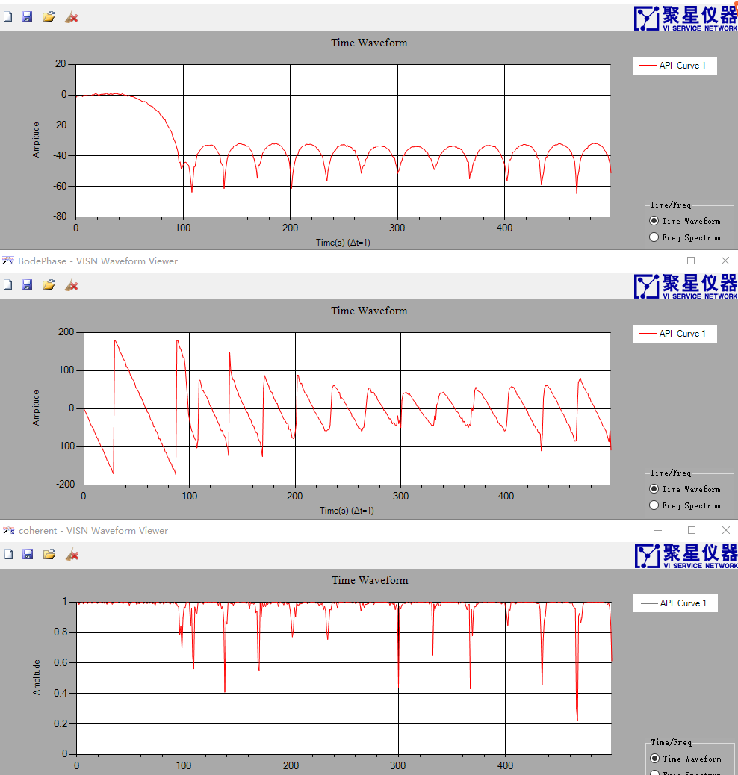
图 4.18系统的幅频响应、相频响应以及相关

HarmonicAnalysis

HarmonicAnalysis介绍
谐波分析包括ToneAnalysis、THDAnalysis、SINADAnalysis。
①ToneAnalysis：计算正弦波的幅值、频率和相位。
②THDAnalysis：分析谐波失真。
③SINADAnalysis：分析信纳比。

范例
/*************************************
* Tone分析 计算信号基波的幅度、相位、频率
* 基波频率为20
* ************************************/
var samplingRate = 1000;
var signalFrequency = 20;
var noiseLevel = 0.2;
var noise = new double[1000];
var signal = new double[1000];
JY.DSP.Fundamental.Generation.SineWave(ref signal, 4, 50, (double)signalFrequency, (double)samplingRate);
ArrayCalculation.AddOffset(ref signal, 2);
var dt = 1 / (double)samplingRate;
JY.DSP.Fundamental.Generation.UniformWhiteNoise(ref noise, noiseLevel);
ArrayCalculation.Add(signal, noise, ref signal);
AnalogWaveformChart.Plot("raw signal", signal);
double fundamentalFreq;
double phase;
double amplitude;
HarmonicAnalysis.ToneAnalysis(signal, dt, out fundamentalFreq,out amplitude,out phase);
Console.WriteLine("fundamentalFrequency={0}", fundamentalFreq);
Console.WriteLine("amplitude={0}", amplitude);
Console.WriteLine("phase={0}", phase);
结果：
fundamentalFreq=19.999813199835433
amplitude=3.9963377884507003
phase=50.079892166637848

/*************************************
* THD分析
* 基波频率为60
* ************************************/
var samplingRate = 1000;
var signalFrequency = 60;
var noiseLevel = 0.2;
var noise = new double[1000];
var signal = new double[1000];
JY.DSP.Fundamental.Generation.SineWave(ref signal, 1, 50, (double)signalFrequency, (double)samplingRate);
ArrayCalculation.AddOffset(ref signal, 2);
var dt = 1 / (double)samplingRate;
JY.DSP.Fundamental.Generation.UniformWhiteNoise(ref noise, noiseLevel);
ArrayCalculation.Add(signal, noise, ref signal);
AnalogWaveformChart.Plot("raw signal", signal);
double fundamentalFreq;
double THD;
double[] componentsLevel = new double[0];
HarmonicAnalysis.THDAnalysis(signal, dt, out fundamentalFreq, out THD, ref componentsLevel);
Console.WriteLine("fundamentalFrequency={0}", fundamentalFreq);
Console.WriteLine("THD={0}", THD);
AnalogWaveformChart.Plot("Analysis", componentsLevel);
结果：
fundamentalFreq=60.0043143232529
THD=0.0362533770383877

/*************************************
* SINAD分析
* 基波频率为60
* ************************************/
var samplingRate = 1000;
var signalFrequency = 60;
var noiseLevel = 0.2;
var noise = new double[1000];
var signal = new double[1000];
JY.DSP.Fundamental.Generation.SineWave(ref signal, 1, 50, (double)signalFrequency, (double)samplingRate);
ArrayCalculation.AddOffset(ref signal, 2);
var dt = 1 / (double)samplingRate;
JY.DSP.Fundamental.Generation.UniformWhiteNoise(ref noise, noiseLevel);
ArrayCalculation.Add(signal, noise, ref signal);
AnalogWaveformChart.Plot("raw signal", signal);
double fundamentalFreq;
double SINAD;
double[] componentsLevel = new double[0];
HarmonicAnalysis.SINADAnalysis( signal, dt, out fundamentalFreq, out SINAD, ref componentsLevel);
Console.WriteLine("fundamentalFrequency={0}", fundamentalFreq);
Console.WriteLine("SINAD={0}", SINAD);
AnalogWaveformChart.Plot("Analysis", componentsLevel);

结果：
fundamentalFreq=59.996122423727464
SINAD=1.0601596233046509

SquarewaveMeasurements

SquarewaveMeasurements介绍
方波测量包括幅值分析、周期分析、相位分析、电平直方图和占空比直方图
①幅值分析：void AmplitudeAnalysis(double[] waveform, out double highLevel, out double lowLevel)
②周期分析：void PeriodAnalysis(double[] waveform, out double period, out double dutyCycleAvg,out double pulseCount, out double pulseMaxWidth, out double pulseMinWidth)
③相位分析void PhaseAnalysis(double[] waveform, double[] waveformRef,out double phase)
④电平直方图：bool GetLevelHistogram(ref double[] histogramX, ref double[] histogramY, Histogram histogramConfig)
⑤占空比直方图：bool GetDutyCycleHistogram(ref double[] histogramX,ref double[] histogramY,Histogram histogramConfig)
⑥上升下降时间：TimeAnalysis(double[] waveform, out double risingSamples, out double fallingSamples);
其中waveform为方波信号，waveformRef为参考方波信号，highLevel为高电平，lowLevel为低电平，period为周期（单位为采样点），dutyCycleAvg为占空比（0~1），pulseCount位脉冲数，pulseMaxWidth为最大脉宽（单位为采样点），pulseMinWidth为最小脉宽（单位为采样点），phase为waveform相对于waveformRef为相位，risingSamples为上升

范例
/**************************
* 产生频率为20Hz，采样率为1000Hz，幅值为2V，占空比为50%的方波
* 测量方波的高电平、低电平、周期、相位
* ***************************/

double[] waveformTmp = new double[1000];
double[] waveformRef = new double[1000];
JY.DSP.Fundamental.Generation.SquareWave(ref waveformTmp, 2, 50, 20, 1000);
JY.DSP.Fundamental.Generation.SquareWave(ref waveformRef, 2, 50, 20, 1000);
double highLevel;
double lowLevel;
double period;
double dutycycle;
double phase;
double pulseCount;
double pulseMaxLength;
double pulseMinLength;
SquarewaveMeasurements.AmplitudeAnalysis(waveformTmp, out highLevel, out lowLevel);
SquarewaveMeasurements.PeriodAnalysis(waveformTmp, out period, out dutycycle,
out pulseCount, out pulseMaxLength, out pulseMinLength);
SquarewaveMeasurements.PhaseAnalysis(waveformTmp, waveformRef, out phase);
double[] levelHistogramX = new double[0];
double[] levelHistogramY = new double[0];
SquarewaveMeasurements.GetLevelHistogram(waveformTmp,ref levelHistogramX, ref levelHistogramY, new SquarewaveMeasurements.Histogram());
for (int j = 0; j < levelHistogramX.Length; j++)
{
Console.WriteLine("{0}:{1}", levelHistogramX[j], levelHistogramY[j]);
}
Console.WriteLine("highLevel:{0}", highLevel);
Console.WriteLine("lowLevel:{0}", lowLevel);
Console.WriteLine("period:{0}", period);
Console.WriteLine("phase:{0}", phase);
结果：
highLevel=2
lowLevel=-2
period=50
phase=0

ThirdOctaveAnalysis

ThirdOctaveAnalysis介绍
1/3倍频程分析

范例
/*****************************
* 产生50Hz的正弦信号
* 做1/3倍频程分析
* 时间平均方式为Fast
* 加权滤波器的类型为A加权
* 中心频率为50即第4频段（从0开始）的能量最高
* ******************************/
double duration = 2; //seconds;
double sampleRate = 51200; //you cannot change this
int dataLength = (int)(duration * sampleRate);
double[] sin1 = new double[dataLength];
JY.DSP.Fundamental.Generation.SineWave(ref sin1, 1.414, 0, 50, sampleRate);
ThirdOctaveAnalysis analysis = new ThirdOctaveAnalysis();
analysis.AverageMode = Conditioning.TimeAveragingMode.Fast;
analysis.WeightingFilterType = WeightingType.AWeighting;
var result = analysis.Analyze(sin1, sampleRate);
double[] octaveLevels = new double[result.ThirdOctaveLevels.Length];
for (int i = 0; i < octaveLevels.Length; i++)
{
octaveLevels[i] = 20 * Math.Log10(result.ThirdOctaveLevels[i]) + 100;
}
AnalogWaveformChart.Plot("Mode=Fast and WeightingFilterType=AWeighting", octaveLevels);
结果:
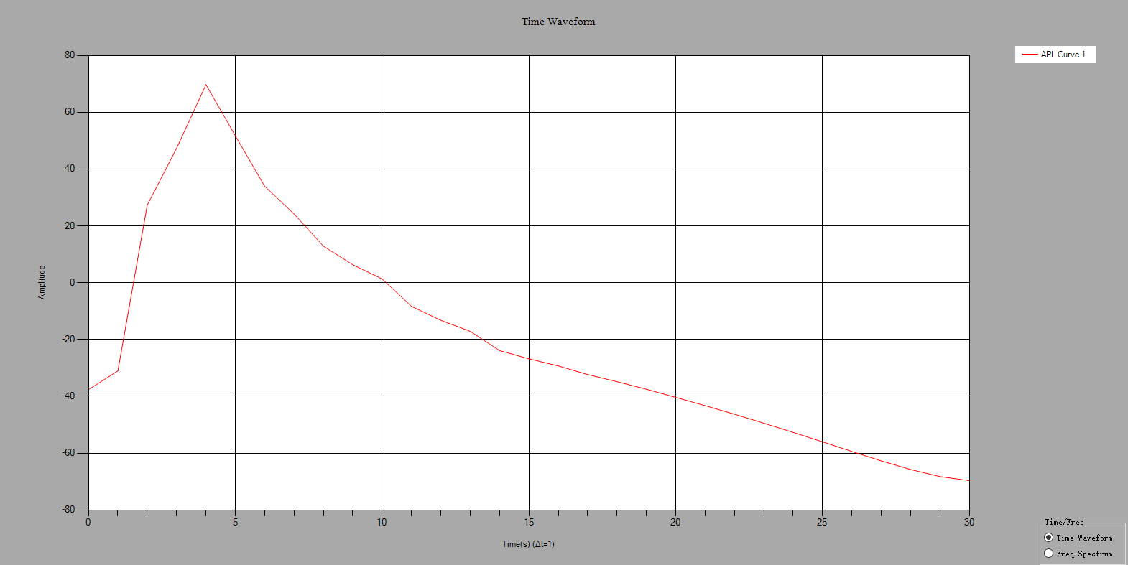
图 4.19 1/3倍频程分析

Spectrum

Spectrum介绍
快速傅里叶转换，可以输出幅度谱和密度谱，窗类型可选择，支持实数/复数输入，输出单位有V2/V/dBV/dbmV/dbuV/W/dBW/dBm，电阻值默认为50欧姆。
注意：实数信号做FFT输出谱线数为输入信号长度的一半，而复数信号做FFT输出谱线数为输入信号长度。

范例
/**********************************
* 产生有2V的直流分量10Hz，1Vpp的正弦波，并加上噪声
* 实数FFT，不加窗，不平均，输出频谱单位为V
* 验证峰值的有效值是不是2V和1/sqrt（2）=0.707V
* ********************************/
int Length = 1000;
double sampleRate = 1000;
double[] sin = new double[Length];
double[] noise = new double[Length];
double[] spec = new double[Length/2];
Generation.SineWave(ref sin, 1, 0, 10, sampleRate);
Generation.UniformWhiteNoise(ref noise, 0.1);
ArrayCalculation.Add(sin, noise, ref sin);
ArrayCalculation.AddOffset(ref sin, 2);
SpectrumTask _task = new SpectrumTask();
_task.InputDataType = InputDataType.Real;
_task.SampleRate = sampleRate;
_task.WindowType = FFTWindowType.None;
_task.Average.Mode = SpectrumAverageMode.NoAveraging;
_task.Average.WeightingType = SpectrumWeightingType.LinearMoving ;
_task.Average.Size = 10;
_task.Output.NumberOfLines = Length/2;
_task.Unit.Type = SpectrumOutputUnit.V;
_task.Unit.Impedance = 50;
_task.Unit.IsPSD = false ;
// _task.Commit();
_task.GetSpectrum(sin, ref spec);
double df = _task.SpectralInfomation.FreqDelta;
double count = _task.SpectralInfomation.FFTCount;
double fftSize = _task.SpectralInfomation.FFTSize;
double fStart = _task.SpectralInfomation.FreqStart;
// VISN_Plot.PlotData("Spectrum1",fStart,df,spec);
AnalogWaveformChart.Plot("Spectrum1",fStart, df, spec);
Peak[] a = new Peak[100];
a=_task.FindPeak(spec, 0.6, 0, 150);
Assert.IsTrue(Math.Abs((2 - a[0].PeakValue) / 2)< 0.01);//直流分量的幅值
Assert.IsTrue(Math.Abs((1/Math.Sqrt(2) - a[1].PeakValue)/ (1 / Math.Sqrt(2))) < 0.01); //正弦信号的有效值
Assert.IsTrue(Math.Abs((10 - a[1].PeakFrequency)/10) < 0.01);//正弦信号的频率

结果：
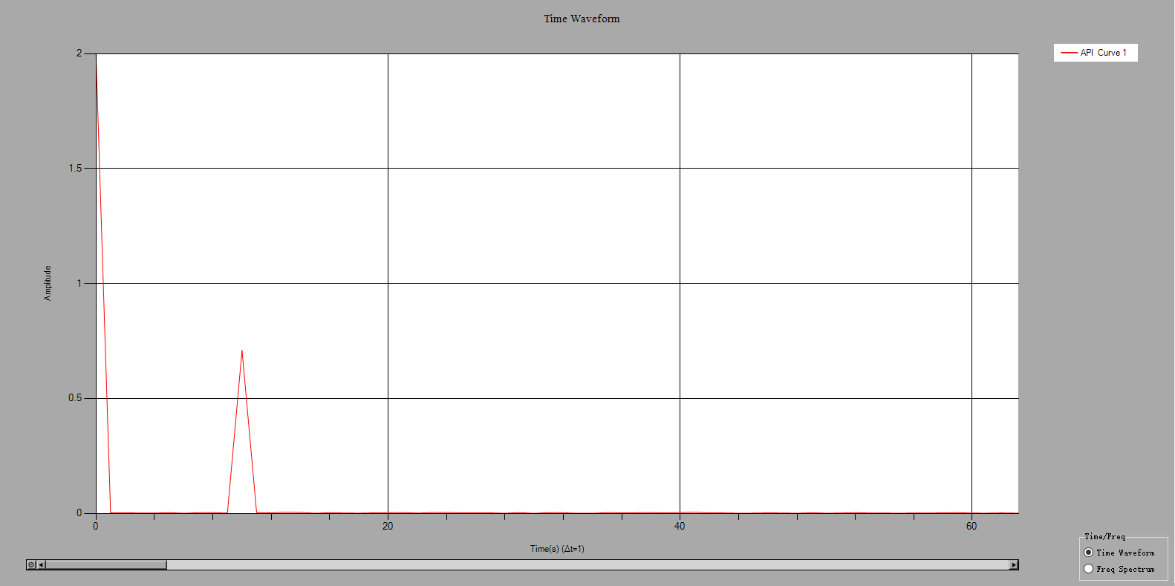
图 5.20 实数FFT

/**********************************
* 产生复数信号，频率为10Hz，直流分量为2V，幅值1Vpp
* 复数FFT，不加窗，不平均，输出频谱单位为V
* 验证峰值的有效值
* ********************************/
int Length = 1000;
double sampleRate = 1000;
double[] sin = new double[Length];
double[] cos = new double[Length];
double[] noise = new double[Length];
double[] spec = new double[Length ];
Generation.SineWave(ref sin, 1, 0, 50, sampleRate);
Generation.SineWave(ref cos, 1, 90, 50, sampleRate);
Generation.UniformWhiteNoise(ref noise, 0.05);
ArrayCalculation.Add(sin, noise, ref sin);
ArrayCalculation.Add(cos, noise, ref cos);
ArrayCalculation.AddOffset(ref sin, 2);
ArrayCalculation.AddOffset(ref cos, 2);
var signal = new Complex[Length];
for (int i = 0; i < Length; i++)
{
signal[i] = new Complex(cos[i], sin[i]);
}

SpectrumTask _task = new SpectrumTask();
_task.InputDataType = InputDataType.Complex;
_task.SampleRate = sampleRate;
_task.WindowType = FFTWindowType.None;
_task.Average.Mode = SpectrumAverageMode.NoAveraging;
_task.Average.WeightingType = SpectrumWeightingType.LinearMoving;
_task.Average.Size = 10;
_task.Output.NumberOfLines = Length;
_task.Unit.Type = SpectrumOutputUnit.V;
_task.Unit.Impedance = 50;
_task.Unit.IsPSD = false;
_task.GetSpectrum(signal, ref spec);
double df = _task.SpectralInfomation.FreqDelta;
double count = _task.SpectralInfomation.FFTCount;
double fftSize = _task.SpectralInfomation.FFTSize;
double fStart = _task.SpectralInfomation.FreqStart;
AnalogWaveformChart.Plot("Spectrum3", fStart, df, spec);
double f0Value = Math.Sqrt (8) ;
double f10Value = 1/Math.Sqrt(2);
Peak[] a = new Peak[100];
a = _task.FindPeak(spec, 0.4, -15, 150);
Assert.IsTrue(Math.Abs((f0Value - a[0].PeakValue) / f0Value) < 0.01);//直流分量的幅值
Assert.IsTrue(Math.Abs((f10Value - a[1].PeakValue) / f10Value) < 0.01); //正弦信号的有效值
Assert.IsTrue(Math.Abs((10 - a[1].PeakFrequency) / 10) < 0.01);//正弦信号的频率

结果：
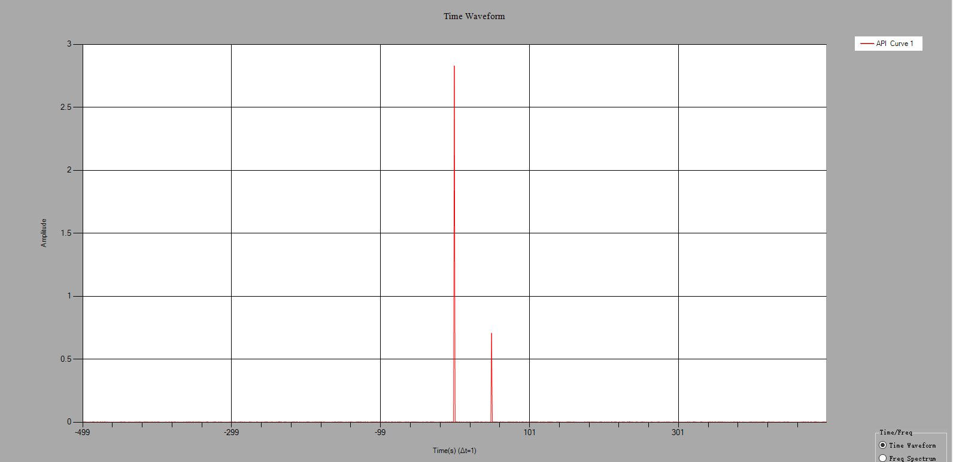
图 5.21 复数FFT

LicenseBase
当工程师利用DSP工具包完成二次开发后，在客户的机器上不想再次激活，可以使用一下代码：

LicenseBase.Validate("ComputerID", "ActiveCode", "ActiveTime");
computerID：
activeCode：
activeTime：完全激活，activeTime=””,临时激活activeTime为秒数

